**LAB 3 TASK**

**Q1) Using ping command finds timeout of your system**

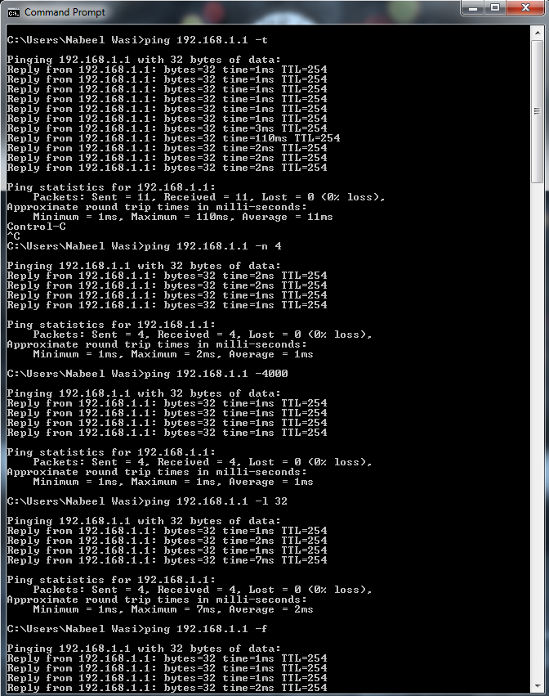

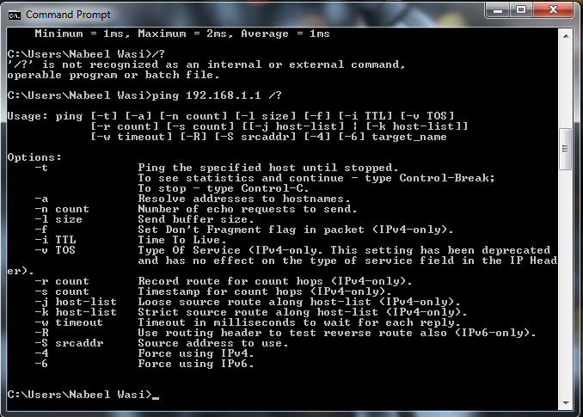

**Q2) Change user password that never expires.**

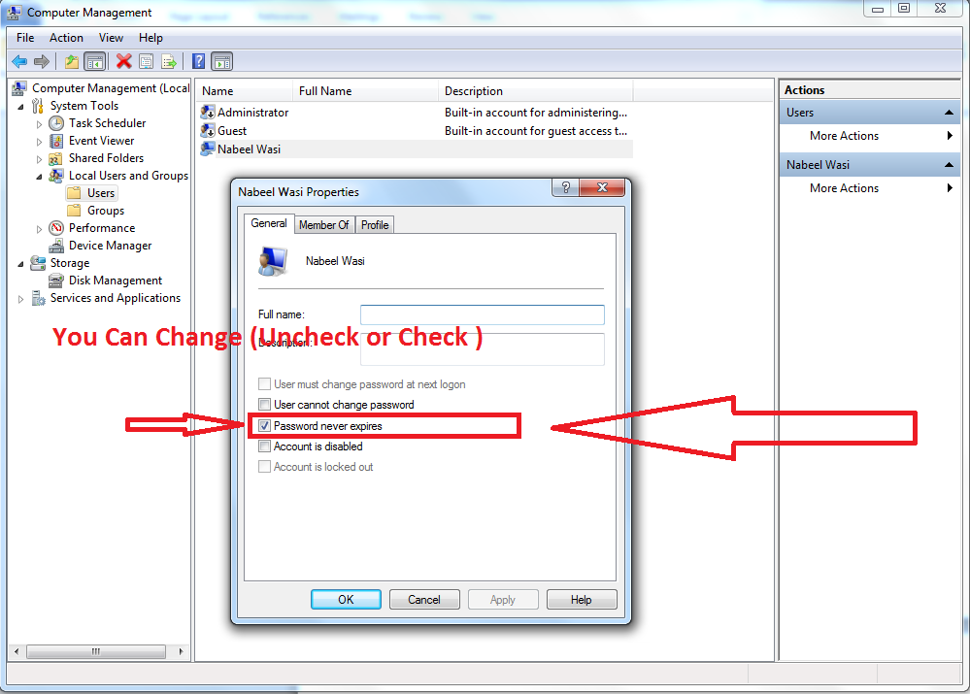

**Q3) Stop services of any three services that are on your operating system.**

